2010 National Collegiate Championships
Northern Michigan University | Marquette, Mich.
April 16-18, 2010

Venue: Berry Events Center
Northern Michigan University
1401 Presque Isle Ave.
Marquette, Michigan 49855
1-906-227-2888

Official Hotel: The Landmark Inn
230 North Front St.
Reservations: 888-752-6362
Information: 906-228-2580
Rate: $99/room + tax
To receive this reduced rate, please refer to “Weightlifting Collegiate
Championships” when making your reservation
www.thelandmarkinn.com/

Transportation: Complimentary shuttles from airport and the hotel and from the hotel to the venue are only available from the Landmark Inn.

Overflow Hotel Country Inn & Suites
Only 2472 US Highway 41 West
Reservations: 1-906-225-1300 (must call direct to get this rate)
Rate: $99/room + tax for regular rooms (Suites are extra)
There no shuttle service provided from the overflow hotel
www.countryinns.com/marquettemi

Meet Director: Mr. Andy Tysz
Phone: 1-906-227-1748
Email: atysz@nmu.edu

Entry Fee: Individual - $50, non-refundable
Team - $75, non-refundable

Qualifying Deadline: Tuesday March 16, 2010 (Note that the qualifying deadline and the
entry deadline are not the same date).

Entry Deadline: Manual entries with original college seal must be postmarked no later than: Thursday, March 18, 2010. On-line entries must be received before midnight MST on March 18, 2010. After midnight, the on-line registration system will not allow you to enter the competition. If entering online, faxing or emailing your entry, Page 9 of manual entry form (available on USA Weightlifting website) must be completed and sent to the National Office with original college seal, postmarked no later than March 18, 2010. Page 9 not acceptable via fax or email.
2010 National Collegiate Championships
Northern Michigan University | Marquette, Mich.
April 16-18, 2010

MEETING INFORMATION

Verification of Final Entries Meeting: Thursday, April 15, 2010
The Landmark Inn
5:30-6:00 p.m. EST

Technical Meeting: Thursday, April 15, 2010
The Landmark Inn
7:00-7:30 p.m. EST

TICKET INFORMATION

Official participants in the competition will receive a credential that will allow access into the venue without charge. All others may purchase tickets in advance at all NMU EZ Ticket Offices or by calling 906-227-1032. Tickets will also be available at the door. The following prices apply:

- Students – free of charge with student ID
- All Others - $2/day or $5/all-event pass

Tentative Schedule of Events

The daily weigh-in and lifting schedule is subject to change. Only weigh-in and lifting times may be changed, not dates. Changes, if needed, will be announced at the Technical Meeting on Thursday, April 15th, 7:00-7:30 p.m.

Friday, April 16, 2010

Session | Gender | Category | Q-Total | Weigh In Time | Lift Time
1 | Women | 48/53 KG | 77/88 kg | 10:00 a.m. | 12:00 p.m.
2 | Men | 56/62 KG | 110/137 kg | 12:00 p.m. | 2:00 p.m.
3 | Women | 58 KG | 96 kg | 2:00 p.m. | 4:00 p.m.
4 | Men | 69 KG | 170 kg | 4:00 p.m. | 6:00 p.m.

Saturday, April 17, 2010

Session | Gender | Category | Q-Total | Weigh In Time | Lift Time
5 | Women | 63 KG | 102 kg | 8:00 a.m. | 10:00 a.m.
6 | Men | 77 KG | 195 kg | 10:00 a.m. | 12:00 p.m.
7 | Women | 69 KG | 104 kg | 1:00 p.m. | 3:00 p.m.
8 | Men | 85 KG | 203 kg | 3:00 p.m. | 5:00 p.m.
9 | Men | 94 KG | 213 kg | 5:00 p.m. | 7:00 p.m.
2010 National Collegiate Championships
Northern Michigan University | Marquette, Mich.
April 16-18, 2010

Tentative Schedule of Events CONT.

Sunday, April 18, 2010

Session | Gender | Category | Q-Total | Weigh In Time | Lift Time
10 | Women | 75 KG | 109 kg | 8:00 a.m. | 10:00 a.m.
11 | Women | 75+ KG | 110 kg | 10:00 a.m. | 12:00 p.m.
12 | Men | 105 KG | 214 kg | Noon | 2:00 p.m.
13 | Men | 105+ KG | 218 kg | 2:00 p.m. | 4:00 p.m.

Airport and Travel Information

Airport Information Saywer International Airport
http://www.sawyerairport.com/departures_and_arrivals.html

Airlines: Mesaba Airlines / The Delta Connection
Ticket Counter: (906) 346-6471
Reservations: (800) 225-2525 / (800) 221-1212

American Eagle Airlines
Reservations: (800) 433-7300
Lost Luggage: (800) 535-5225

Transportation Complimentary shuttle service will be provided from the Sawyer Airport to the Landmark Inn only. We require 48 hours notice prior to your arrival to coordinate this service. To submit travel information please call 906-227-2893 or email USOEC@nmu.edu.

Event Transportation will be provided only from the Landmark Inn to the Berry Evnts Center on Friday, April 16, Saturday, April 17, and Sunday, April 18. A specific timeline will be posted at the host hotel and the Berry Events Center.

2010 National Collegiate Championships
Northern Michigan University | Marquette, Mich.
April 16-18, 2010

National Car Rental
(906) 346-6378
(800) 227-7368
www.nationalcar.com
Alamo Rent-A-Car
(800) 462-5266
www.alamo.com
Car Rentals:
Thrifty Car Rental
(906) 346-4355
(800) 847-4389
www.thrifty.com

Budget Rent-A-Car
(906) 372-9240
(800) 527-7000
www.budget.com

Avis Rent-A-Car
(906) 346-6398
(800) 831-2847
www.avis.com

Official Hotel Information

The Landmark Inn
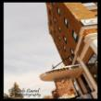
Restored to its original splendor, the historic Landmark Inn is the crown jewel of beautiful Marquette, Michigan and welcomes travelers with a unique combination of old-world charm and modern-day convenience. The timeless world of European-inspired elegance is reflected in the individually designed guest rooms (many with Jacuzzis, fireplaces and spectacular views of majestic Lake Superior). Their entire hotel is 100% Smoke Free.

The historic Landmark Inn has served the famous and infamous from Amelia Earhart and Abbott and Costello, to Louis Armstrong, and The Rolling Stones.

• Rooms & Amenities
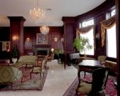
Guest Room Amenities Include: Complimentary High Speed Internet, Coffee and Tea, Hair Dryer, Iron and Board, Soaps, Shampoo and Lotion, Cable and HBO, A Good Night Sweet, 10% off Coupon to utilize in either of our restaurants or lounge, excluding alcohol.

Additionally, guests get use of Northern Michigan University's Physical Education Instructional Facility, including a state of the art fitness center, lap pool, men and women's saunas, indoor climbing wall, racquetball courts and more.

2010 National Collegiate Championships
Northern Michigan University | Marquette, Mich.
April 16-18, 2010

Official Hotel Information Cont.

• Restaurants – The Landmark Offers Two
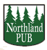

Northland Pub
The authentic English pub furniture and stained glass windows provide a back drop for warm memories with good friends. You will find a variety of tasty fare, from salads and sandwiches to hearty hot entrees & daily specials.

Pub Specials
Wednesday – Mexican Thursday – Ribs Friday - Fish Fry Saturday - Prime Rib

Capers
Join us for breakfast or dinner at Capers Restaurant, open 7 days a week, where flavor and fun are combined offering Classic cuisine with a New Age twist. The atmosphere alone is worth the visit, but the real beauty of the restaurant can be discovered when the menu is explored and the food enjoyed.

Capers’ Hours of Operation:
Breakfast Dinner
Sunday Sunday - Thursday
6:30 a.m. to 1 p.m. 5 p.m. to 9 p.m.

Monday - Saturday Friday-Saturday
6:30 a.m. to 11 a.m. 5 p.m. to 10 p.m.

Location
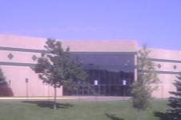
The Landmark Inn is situated downtown Marquette, only a short distance from Lake Superior, several shopping and restaurant establishments and twelve blocks (0.8 miles) from the competition venue – the Berry Events Center.

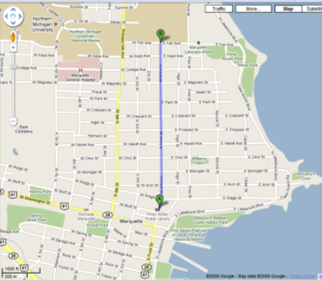

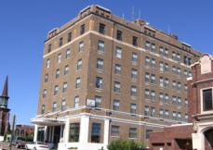

2010 National Collegiate Championships
Northern Michigan University | Marquette, Mich.
April 16-18, 2010

Official Hotel Information Cont.

Other Restaurants within Walking Distance of the Landmark Inn:

- Elizabeth’s Chop House – 113 South Front Street
- Vierling Restaurant & Brewery‎-119 South Front Street
- L’Attitude – 105 E. Washington Street
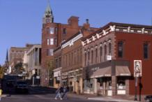
- Up Front & Company – 102 East Main Street
- Wild Rover Public House & Bistro -142 West Washington Street
- Doghouse Pub – 154 West Washington Street
- Lagniappe Cajun Creole Eatery - 145 Jackson Cut Alley
- Portside Inn – 239 West Washington Street
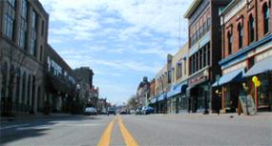
- Aubrees Pizza – 227 West Washington Street

Competition Venue- Berry Events Center
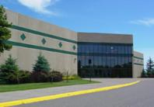

Berry Event Center
The Berry Events Center, which opened its doors in October 1999, is home to the NMU men’s and women’s basketball teams, hockey team and the USOEC short track speedskating squad. The facility is named in honor of the John Berry family, who made a gift of $2 million to Northern Michigan University to help build the facility
The facility provides individual seating for approximately 3,800 fans, in addition to seats in 16 luxury boxes. Along the perimeter of the arena are four large concession areas, as well as standing room for approximately 400 fans.

2010 National Collegiate Championships
Northern Michigan University | Marquette, Mich.
April 16-18, 2010

Competition Venue- Berry Events Center Cont.

Competition Area
The competition platform and warm-up area will be situated on the main floor of the Berry. The diagram below shows the layout of the equipment.

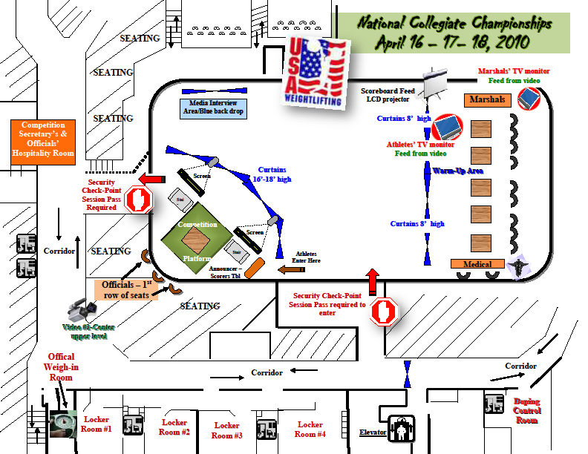
Main Entrance

Main Entrance

2010 National Collegiate Championships
Northern Michigan University | Marquette, Mich.
April 16-18, 2010

Competition Venue, Credentials and Session Passes

Expanded View of Competition Platform
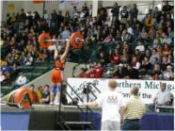
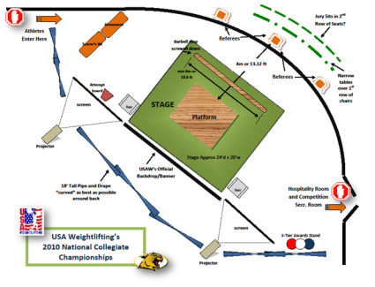
The diagram below shows the general layout of the competition platform, the side and direction athletes enter this area and the two video screens on either side of the stage area. The pictures are from a multi-sport event the USOEC conducted in the Berry Events Center where weightlifting was one of the featured sports.
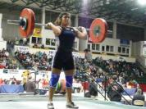

Credential and Session Passes
Each competing athlete and qualified coach will be issued an official credential (see sample to the left) which will allow access on the official event shuttle from the Landmark Inn, access to the competition venue free of charge, access to the training room in the Superior Dome, and access on the main floor for those who also have that day’s proper session pass.

Each confirmed participant will be issued an information packet which can be picked up at the Landmark Inn. Inside this packet will be your credential and lanyard.

USA Weightlifting will issue each competitor’s session passes after each weight class’s official weigh-in time. The session passes should be slid into the sleeve of the credential and shown to the check-point person in order to access the main floor.

