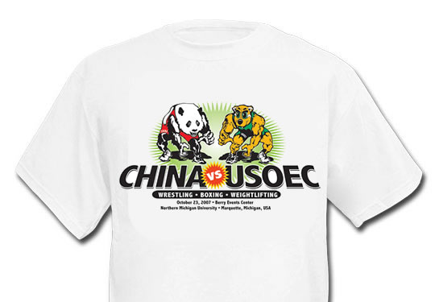
Item: China vs. USOEC Event T-shirt
Description: Event logo on front
Colors: White, Grey
Sizes: S, M, L, XL, 2XL, 3XL
Price: $16
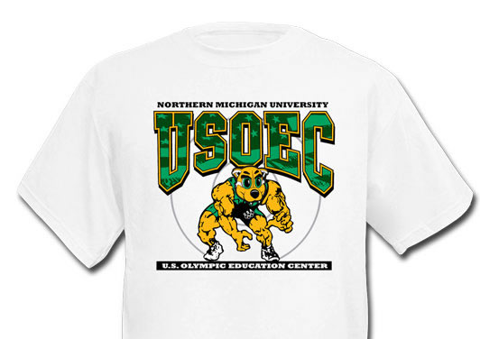
Item: Wrestling Willy T-shirt
Description: Willy on the front with the Olympic Rings on the back collar.
Colors: White, Grey
Sizes: S, M, L, XL, 2XL, 3XL
Price: $16
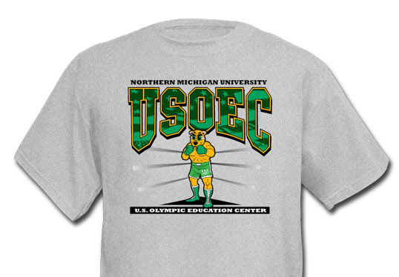
Item: Boxing Willy T-shirt
Description: Willy on the front with the Olympic Rings on the back collar.
Colors: White, Grey
Sizes: S, M, L, XL, 2XL, 3XL
Price: $16
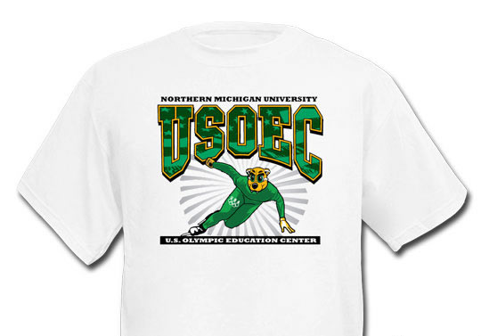
Item: Speedskating Willy T-shirt
Description: Willy on the front with the Olympic Rings on the back collar.
Colors: White, Grey
Sizes: S, M, L, XL, 2XL
Price: $16
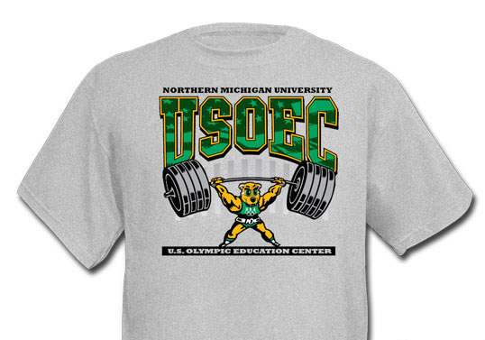
Item: Weightlifting Willy T-shirt
Description: Willy on the front with the Olympic Rings on the back collar.
Colors: White, Grey
Sizes: S, M, L, XL, 2XL, 3XL
Price: $16
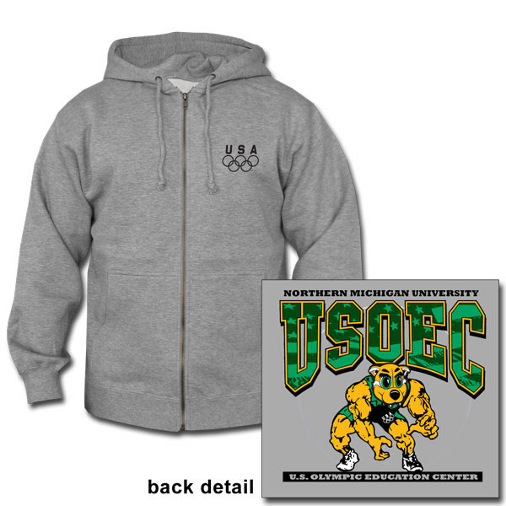
Item: Wrestling Willy Hoodie
Description: Willy on the front with the Olympic Rings on the back collar.
Colors: White, Grey
Sizes: S, M, L, XL, 2XL, 3XL
Price: $45

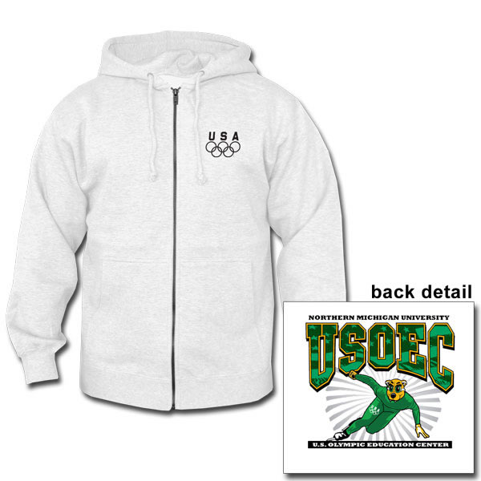
Item: Speedskating Willy Hoodie
Description: Willy on the front with the Olympic Rings on the back collar.
Colors: White, Grey
Sizes: S, M, L, XL, 2XL
Price: $45

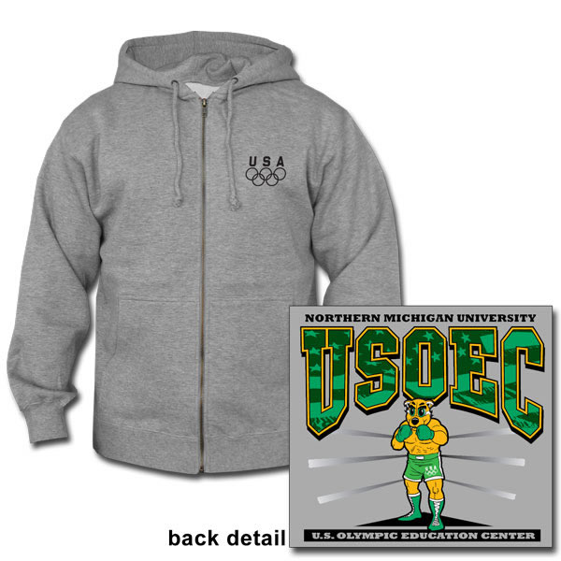
Item: Boxing Willy Hoodie
Description: Willy on the front with the Olympic Rings on the back collar.
Colors: White, Grey
Sizes: S, M, L, XL, 2XL, 3XL
Price: $45

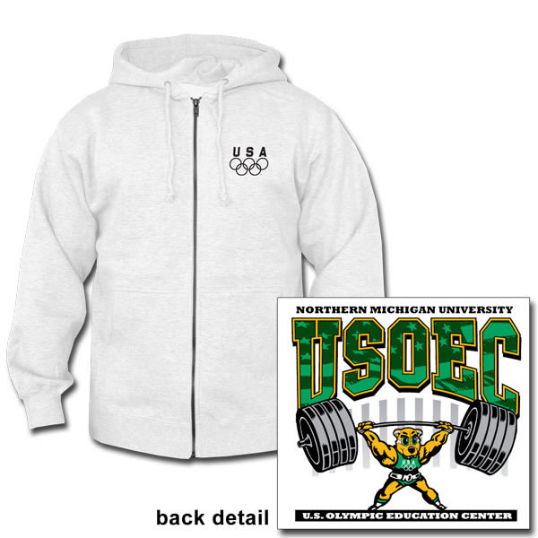
Item: Weightlifting Willy Hoodie
Description: Willy on the front with the Olympic Rings on the back collar.
Colors: White, Grey
Sizes: S, M, L, XL, 2XL, 3XL
Price: $45

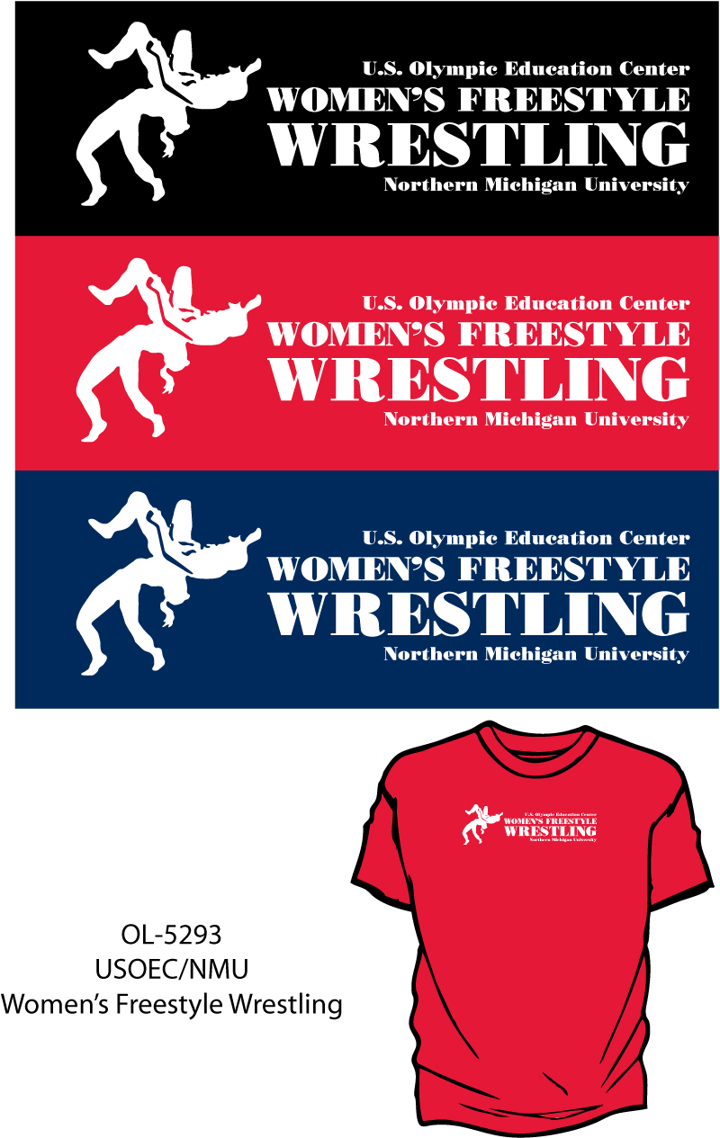
Item: Women’s Freestyle Wrestling T-shirt
Description: Sport on the front with Olympic Rings on the back collar
Colors: Red, Black, Navy
Sizes: S, M, L, XL, 2XL, 3XL
Price: $16

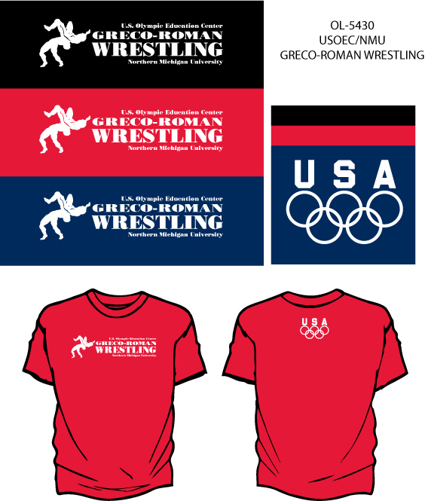

Item: Greco-Roman Wrestling T-shirt
Description: Sport on the front with Olympic Rings on the back collar
Colors: Red, Black, Navy
Sizes: S, M, L, XL, 2XL, 3XL
Price: $16

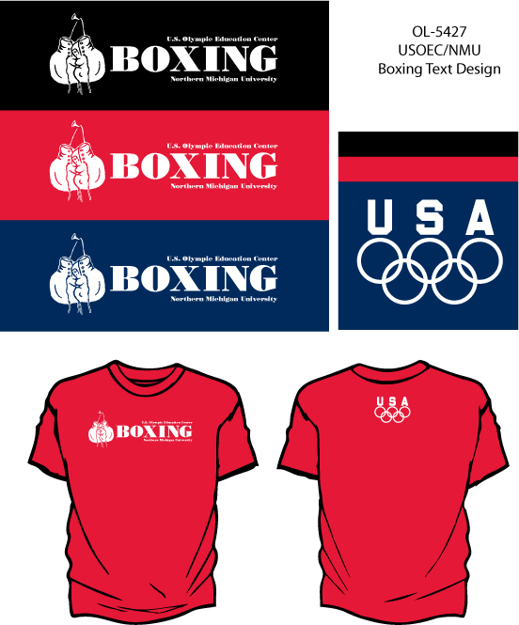

Item: Boxing T-shirt
Description: Sport on the front with Olympic Rings on the back collar
Colors: Red, Black, Navy
Sizes: S, M, L, XL, 2XL, 3XL
Price: $16

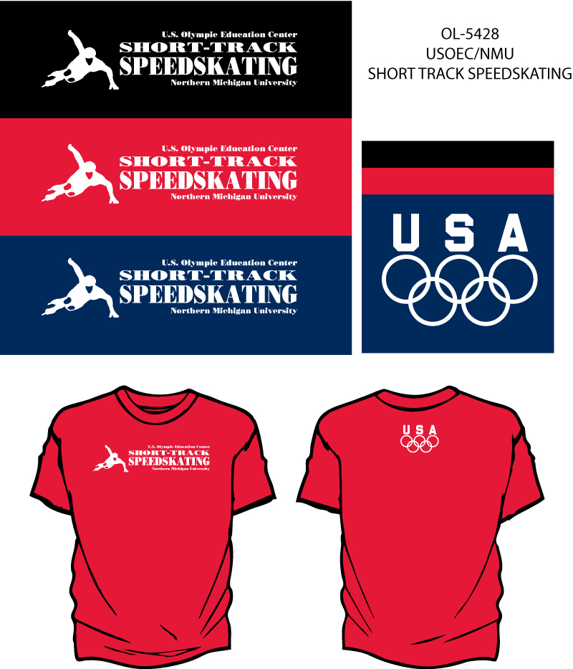
Item: Speedskating T-shirt
Description: Sport on the front with Olympic Rings on the back collar
Colors: Red, Black, Navy
Sizes: S, M, L, XL, 2XL
Price: $16

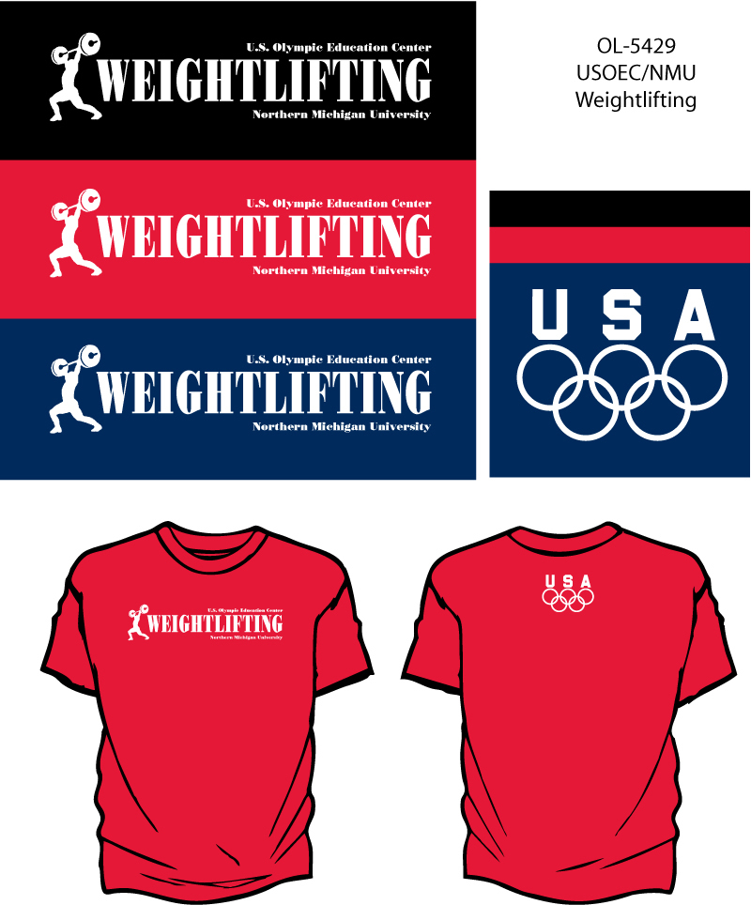
Item: Weightlifting T-shirt
Description: Sport on the front with Olympic Rings on the back collar
Colors: Red, Black, Navy
Sizes: S, M, L, XL, 2XL, 3XL
Price: $16

